Tenda F3--How to bind the IP address with your device

User Scenario:
When other device is connected with router, the DHCP server of router will allot an IP address in its Network segment, 192.168.0.x as default. You can bind some IP address with your device so that the IP address is for your device only. Also, your device would get a fixed IP address.

Step 1: Enter the configuration page of your router.

- Open a browser then type “192.168.0.1” into the Address Bar, press Enter. Then enter the password of this page. Tap “Login”.

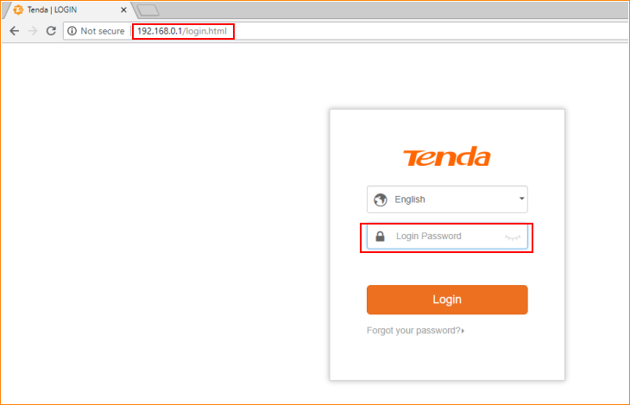

Note: The default password is shown on the bottom of the router. If you have changed it and you also forgot it, see “Forget your password?” below the “Login” button.

- Then the interface will turn into the homepage, tap “Advanced”. You can see “Static IP” in this page.

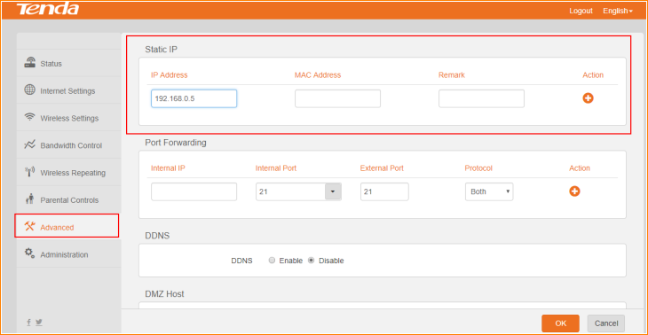

Step 2: Bind one IP with your device. Type the IP address you want to bind for your device in “IP Address” bar, and type the MAC in “MAC Address” bar, and tap the button below “Action” to apply it. Then tap “OK” to save these settings.

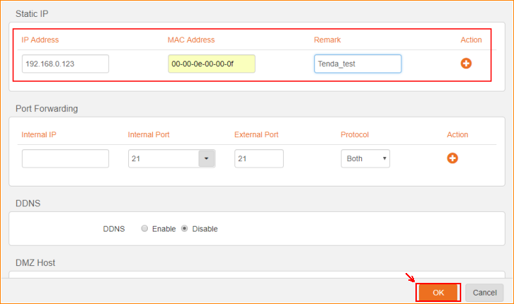

Step 3: Then you can see the IP address successfully bind to your device via its MAC address.

